Dear Santosh Moily & Family,

Please find below my wedding invitation. I would be honored by your presence.

[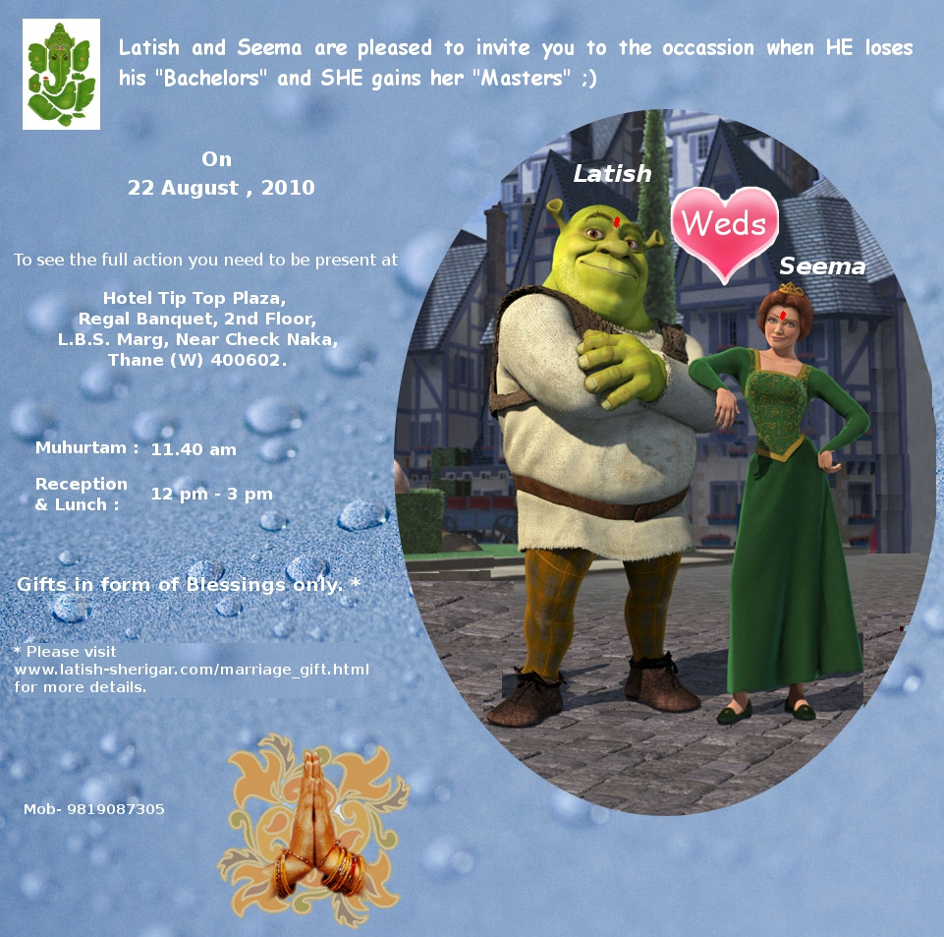](http://www.latish-sherigar.com/marriage_gift.html)

Here are some of your friends who are also invited.

Santosh Moily & Family, Prashita Sherigar & Family

|  |
| --- |
| Regards, |
| Latish |